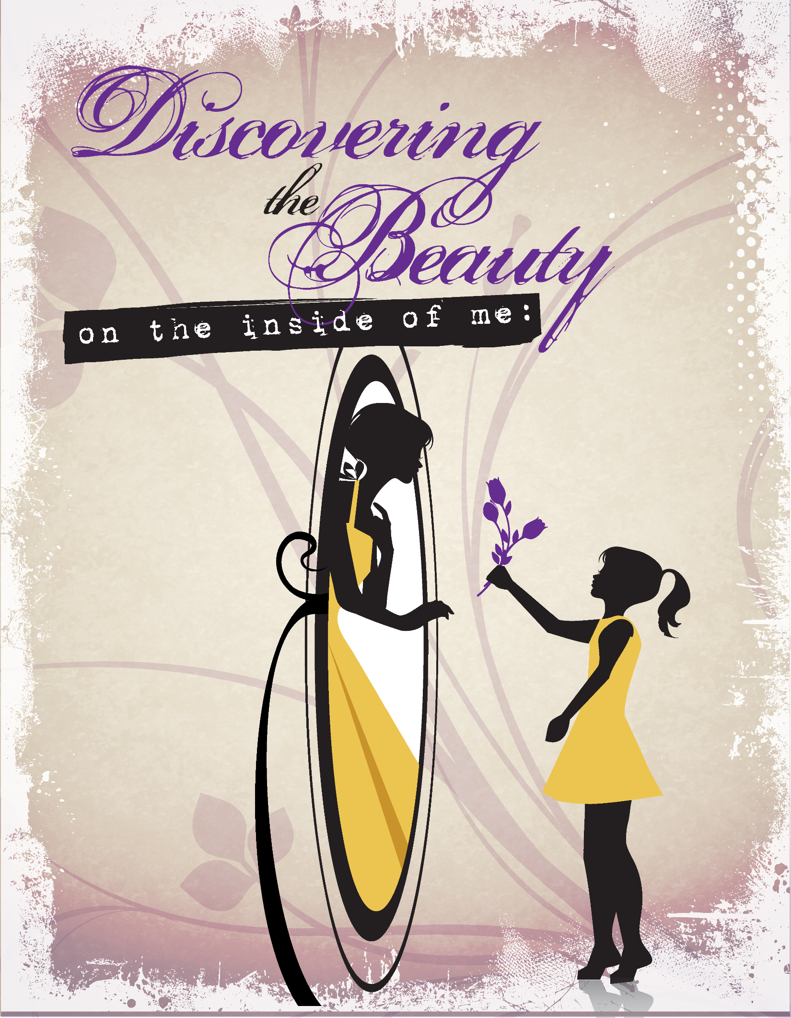

Inspiring young ladies to walk in their Confidence, Boldness, & God given POWER!

“Discovering the Beauty on the Inside of Me”

Author Jennifer Smith

Insert of the journal:

As a little girl I struggled with low self-esteem. I was a big girl growing up. I wasn’t a little slim girl. I was a bit large for my age. To be honest with you, I wasn‟t aware of my unattractiveness until I got a little older. While I was in elementary school, I carried on without knowing I wasn’t the one that most would label as a pretty little girl. I played with my friends, laughed and enjoyed life. It wasn’t not until I reached middle school, 6th grade, that I started to feel I wasn’t as pretty as the other girls.

As suicide attempts are on a rise and our youth are struggling. They are crying out for help, love and support. Many of our young people struggle with the separation of their parents, bullying in school, illnesses, failures, and disappointment.

With that in mind I developed a passion to help our youth. I believe if I would have valued & loved myself more, I would have made better choices. Thus the Beauty in Me journal was developed. Within the Beauty in Me journal we focus on various areas to help build a strong powerful young lady, reaching your dreams, goal setting, positive public speaking, the importance of staying healthy and fit, etiquette, hygiene, abstinence & purity, & the importance of walking with confidence boldness & POWER.

The Beauty in Me journal was designed to inspire young ladies to love and honor themselves. Through a series of chapters, young ladies will read the journal and adopt daily affirmations that encourage them to reach their, dream life. Through this awesome journal, young ladies are inspired to speak positive affirmations pertaining to their life. The affirmations the girls select encourages them to think positive and speak positively about their life. This journal encourages girls to overcome their fears.

Nevertherless, this journal is design to help young ladies realize they can do anything if they set their mind to it. It is my prayer through this journal that young girls will feel better about themselves. I’m believing, that the impact of this journal will be amazing!

Also, if you are interested in being apart of our Beauty in Me program. Please visit us at www.beautyinme.org or follow us on Instagram & twitter at beautyinmeinc or friend us on FB beautyinme.inc.

Thank you!

Jennifer Smith
Founder & Author
Beauty in Me Inc.
P.O. Box 161191
Atlanta, GA 30321
Phone: 404.883.5334

I know the Lord will continue to guide you to fulfill your goals for your vision of Beauty in Me! God Bless you and Beauty in Me!
Parent Andrea Cobb Mother of Arielle Cobb

